9/21/2026
Instructor: Sir Mustajab
Submitted by: Wasif Ali
Reg id: 245187
Class: BSCS F24 B


PYTHON
Artificial Intelligence Lab 03
Lab No 03
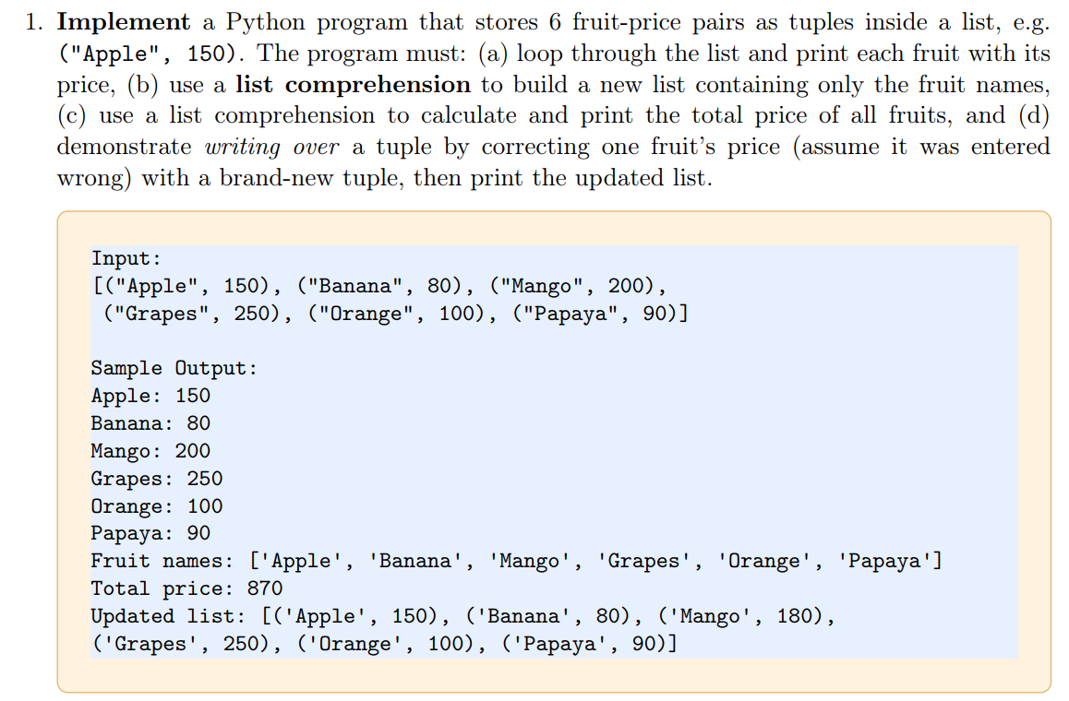
Code:
fruits = [("Apple",150),
("Banana", 80),
("Mango", 200),
("Grapes",250 ),
("Orange", 100),
("Papaya", 90)
]

#a
for fruit in fruits:
print(fruit)

#b
names = [fruit[0] for fruit in fruits]
print("Fruit names: ", names)

#c
prices = [fruit[1] for fruit in fruits]
print("Total price:", sum(prices))

#d
fruits[2] = ("Mango", 180)
print("Updated list:",fruits)

Output:
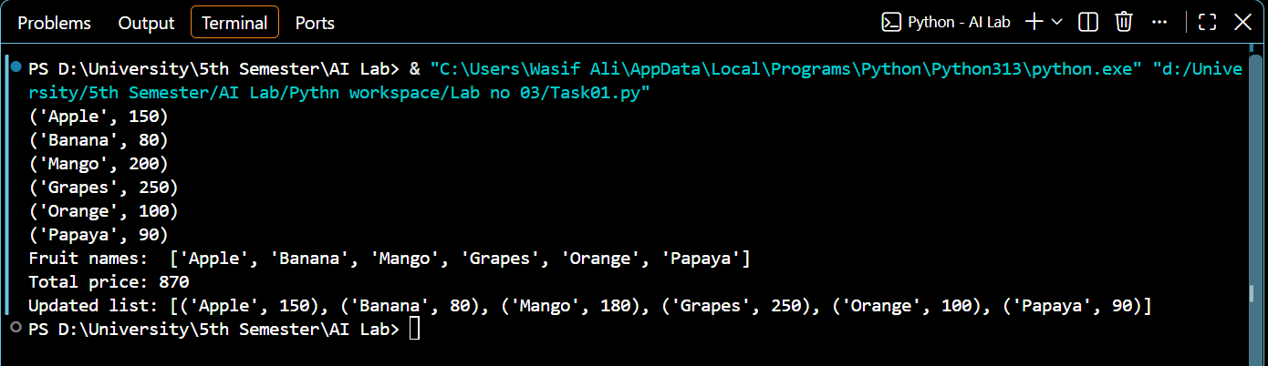

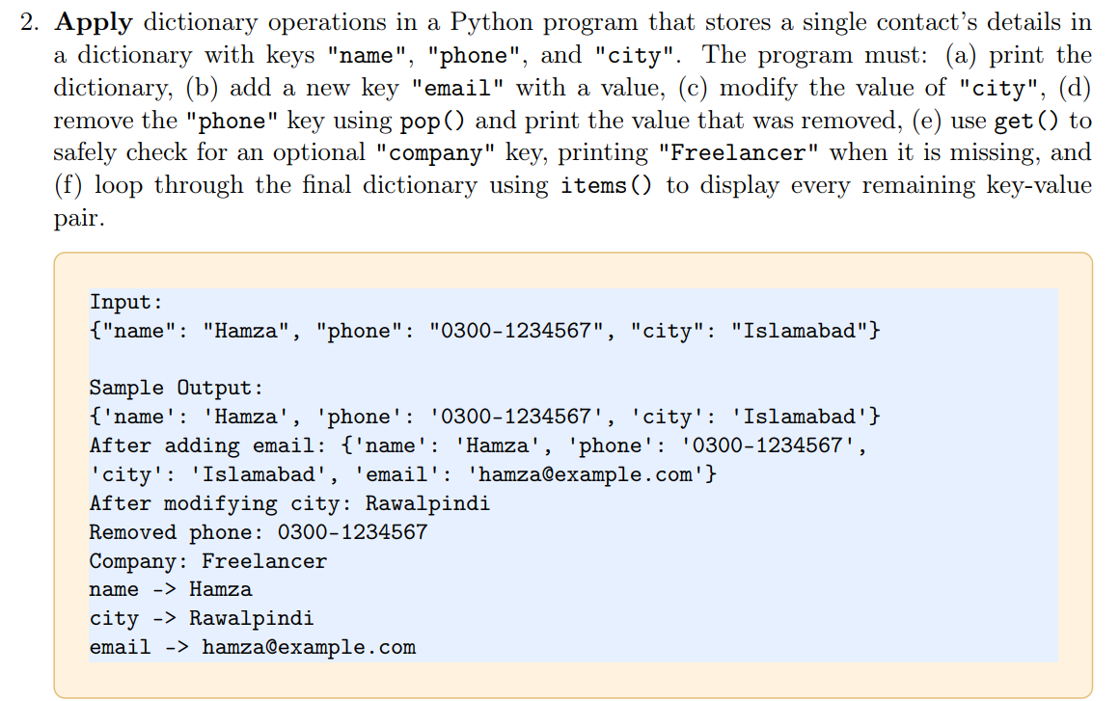

Code:

contact = {"name": "Hamza",
"phone": "0300-1223123",
"city": "Islamabad"
}

#a
print(contact)

#b
contact["email"] = "245187@aack.au.edu.pk"
print("After adding email:" , contact)

#c
contact["city"]= "Rawalpindi"
print("After modifying city:" , contact["city"])

#d
removed_phone = contact.pop("phone")
print("Removed phone:", removed_phone)

#e
print("Company:", contact.get("company","Freelancer"))

#f
for key, value in contact.items():
print(key, "-->",value)

Output:
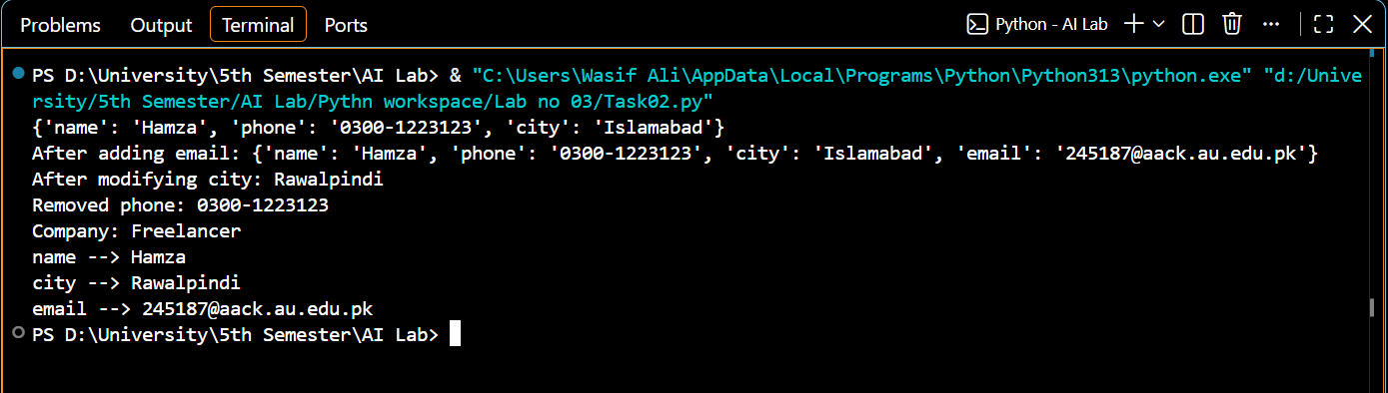

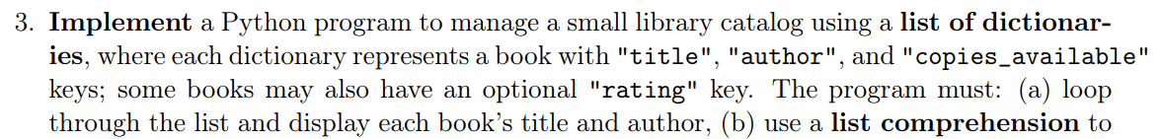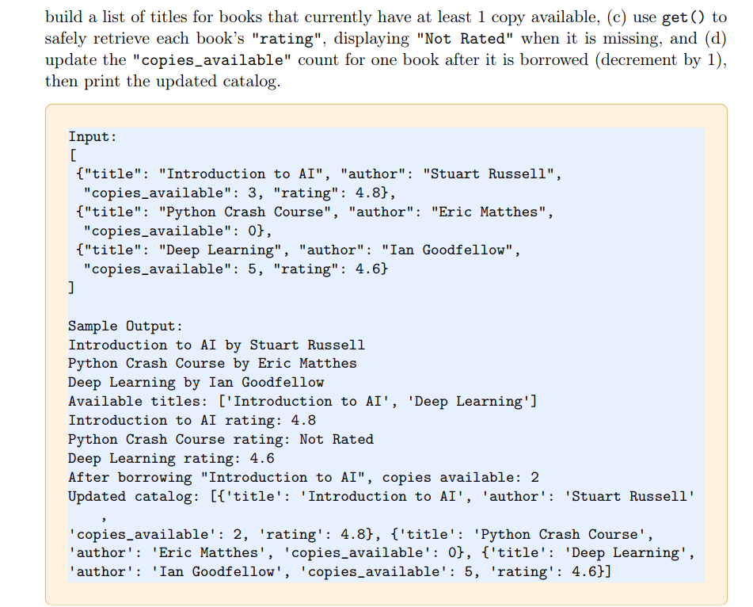
Code:
catalog = [
{"title": "Introduction to AI", "author": "Stuart Russell",
"copies_available": 3, "rating": 4.8},
{"title": "Python Crash Course", "author": "Eric Matthes",
"copies_available": 0},
{"title": "Deep Learning", "author": "Ian Goodfellow",
"copies_available": 5, "rating": 4.6}
]

#a
for book in catalog:
print(book["title"],"by", book["author"])

#b
avaible_titles = [book["title"] for book in catalog if book["copies_available"] >= 1]
print ("Available titles:", avaible_titles)

#c
for book in catalog:
print(book["title"], "rating:", book.get("rating", "Not Rated"))

#d
catalog[0]["copies_available"]-=1
print('Copies available:', catalog[0]["copies_available"])
print("Updated catalog:", catalog)

Output:
